1. Do you agree with the chief software engineer of the department's position on the issue? **[2]**
2. If yes, could you explain why his position was so crucial? **[3]**

**Question 2:** **(CLO2)**  **[5]**

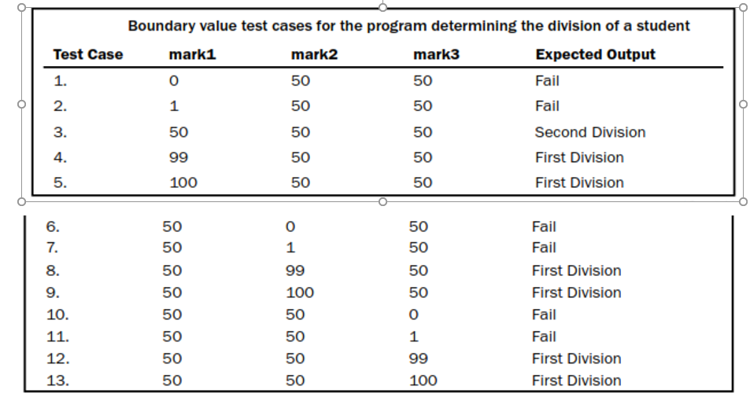

**Question 3: (CLO1) [5]**

Software Quality goals, their relationships, and attributes are invariant across applications. Write Some generic Quality goals of all phases of software development and discuss their any two attributes and respective metrics.

|  |  |  |
| --- | --- | --- |
| **Goal** | **Attribute** | **Metric** |
| Requirement  quality | Ambiguity | Number of ambiguous modifiers |
|  | Completeness | Number of TBA, TBD |
|  | Understandability | Number of sections/subsections |
|  | Volatility | Number of changes per requirement Time (by activity) when change is requested |
|  | Traceability | Number of requirements not traceable to design/code |
|  | Model clarity | Number of UML models  Number of descriptive pages per model  Number of UML errors |
| Design quality | Architectural integrity  Component completeness  Interface complexity  Patterns | Existence of architectural model  Number of components that trace to architectural model, Complexity of procedural design  Average number of pick to get to a typical function or content Layout appropriateness  Number of patterns used |
| Code quality | Complexity  Maintainability  Understandability  Reusability  Documentation | Cyclomatic complexity  Design factors  Percent internal comments, Variable naming conventions  Percent reused components  Readability index |
| QC effectiveness | Resource allocation  Completion rate  Testing effectiveness | Staff hour percentage per activity  Actual vs. budgeted completion time  Number of errors found and criticality, Effort required to correct an error, Origin of error |

**Question 4: (CLO1) [2.5*4=10]**

1. What is Software Quality? List four reasons why software quality matters?

Pressman believes that Software quality is : “Conformance to explicitly stated functional and performance requirements, explicitly documented development standards, and implicit characteristics that are expected of all professionally developed software”. Reasons:

* Safety
* Cost
* Customer satisfaction
* Future value

1. What is the relationship between error, fault and failure? Identify the following as error, fault and failure.
2. Inappropriate data definition fault
3. In a bank application if the Amount Transfer module is not working for end-users when the end-user tries to transfer money, submit button is not working. failure
4. developer misunderstood the requirement error
5. Lack of resources fault



1. "Useless software can be entirely bug free, yet remain entirely useless. Useful software can be ridden with bugs, yet remain highly valuable". This saying concludes that defects are natural in software but there must be some ways to deal with. We discussed three generic ways to deal with defects: write each of three with their one QA activities.

Solution:Defect prevention through error blocking or error source removal

Defect reduction through fault detection and removal

Defect containment through failure prevention and containment

1. What the cost of quality means? Classify each of the following quality costs as prevention costs, appraisal costs, internal failure costs, or external failure costs.

Cost of Quality offers managers a financial method to evaluate the level of their quality and the costs associated with different levels of quality.

1. Quality improvement projects prevention
2. Re-inspection of reworked products internal
3. payment for damages arising from the use of defective products external
4. Supervision of testing and inspecting activities appraisal

**Best of luck!!!!!**